**Week 5**

**Microservices with Spring Boot 3 and Spring Cloud**

***Creating Microservices for account and loan***

Account Microservice

AccountController.java

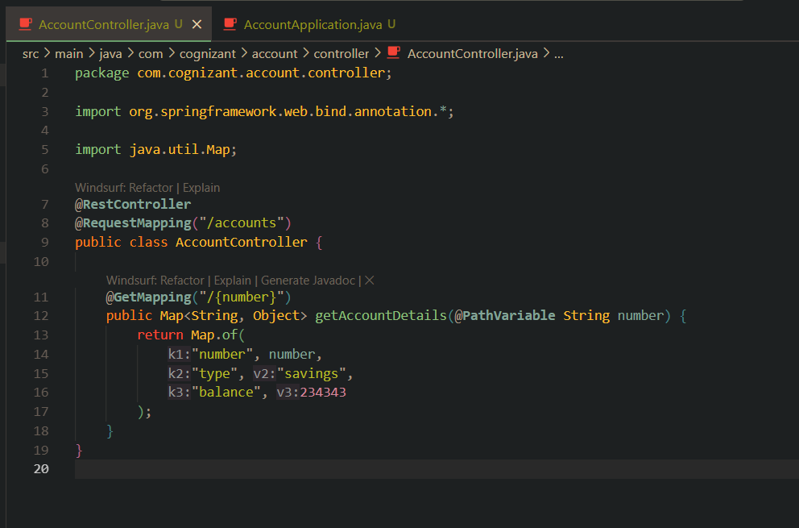

Output

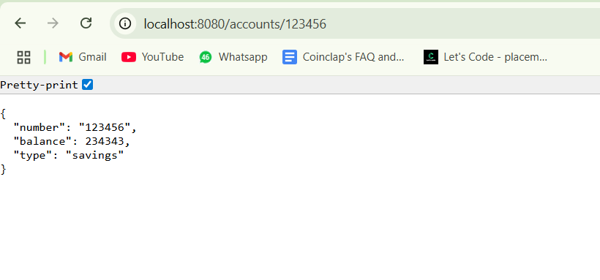

Loan Microservice

LoanController.java

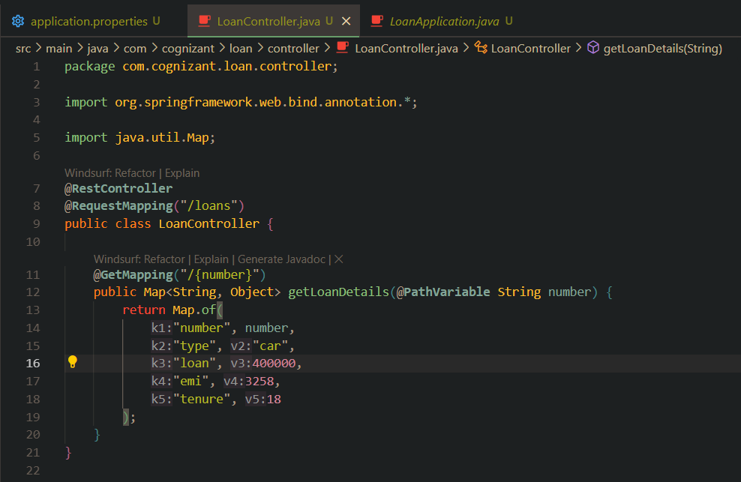

application.properties

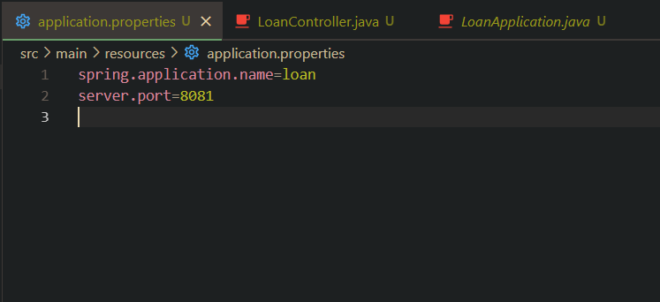

Output

